TEAM NAME:
IF COMPANY SPONSORED:
NAME OF COMPANY:___________________________________CONTACT PERSON: __________________________
ADDRESS: ______________________________________________________________________________
_______________________________________________________________________________________________
TELEPHONE:_______________________________________ EMAIL: __________________________________________

NAME:_________________________________________ TELEPHONE:_____________________________________
ADDRESS:_______________________________________________________________________________________
_______________________________________________EMAIL:__________________________________________

NAME:_________________________________________ TELEPHONE:_____________________________________
ADDRESS:_______________________________________________________________________________________
_______________________________________________EMAIL:__________________________________________

NAME:_________________________________________ TELEPHONE:_____________________________________
ADDRESS:_______________________________________________________________________________________
_______________________________________________EMAIL:__________________________________________

NAME:_________________________________________ TELEPHONE:_____________________________________
ADDRESS:_______________________________________________________________________________________
_______________________________________________EMAIL:__________________________________________

RALLY ‘ROUND
THE CHILLIWACK FOUNDATION
PHOTO + SCAVENGER HUNT
Sunday, September 14, 2025
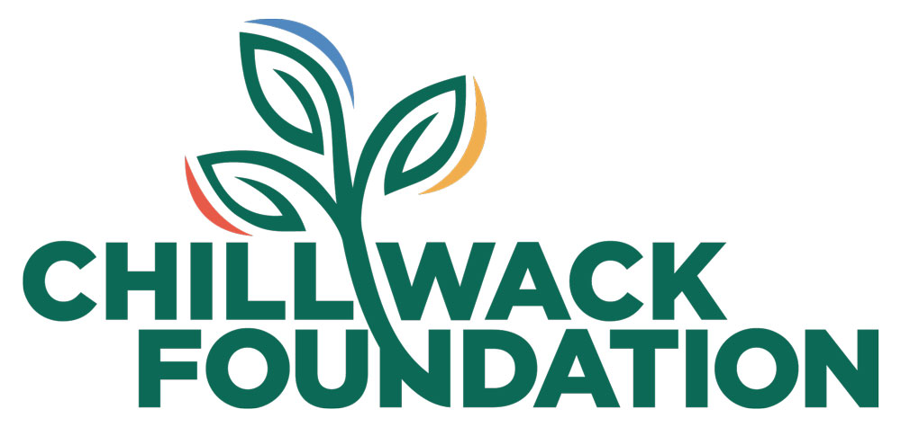

TEAM MEMBERS

TEAM MEMBERS

Please submit
Application, signed waivers, and cheque payable to
CHILLIWACK FOUNDATION
c/o MNP LLP Accountants
45780 Yale Road West
Chilliwack BC V2P 2N4
$100.00 per person or $400.00 per Company
Tax receipts issued for $75 per person or $300 per Company

